Art For Nature: A Fab Friend’s Guide to Gift Giving
Project Activity Plan for Teachers
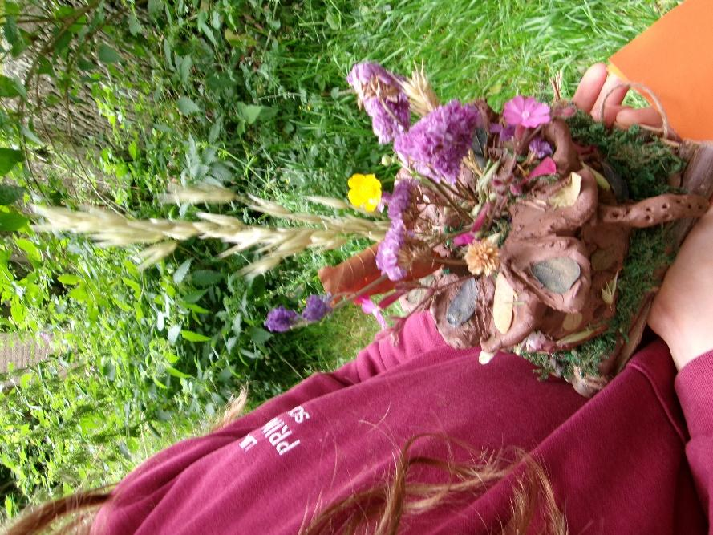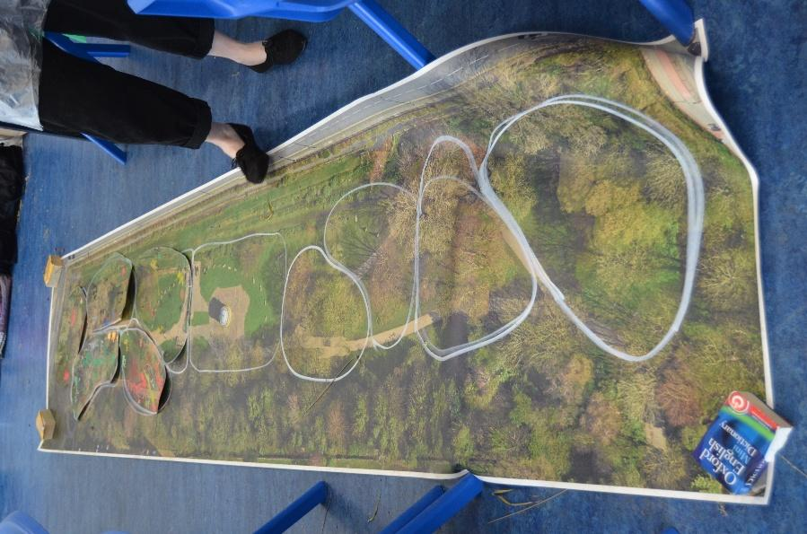
The activity plan below is an informal guide for teachers who might wish to try the ‘Fab Friend’s Guide to Gift Giving’ art and nature themed project with your students. The activities are cross-curricular, combining both Art and Science, and have been designed for Key Stage 2 students, however the activities could also be adapted for younger or older groups.
We suggest delivering the project across 3 extended sessions (2-3 hours each) We delivered our project across 3 morning blocks (periods 1-3 with student morning breaktime as normal)
- Session 1 Fieldwork in a local greenspace (2- 3 hours)
- Session 2 and 3- Design (1 hour) & Sculpture Making (allow 2-3 hours for each sculpture making session- 2 sessions)
Session 1: Fieldwork
Objective:
- To explore wildlife in our local greenspace- investigating who our animal, bird and insect neighbours are and how they live

Materials-
- student fieldwork booklets
- large map of your local greenspace divided into approximately 6 patches that students will explore in groups
- magnifying glasses (if you have access to them)
- tape measures/ rulers (if you have access to them)
- something for students to write with in fieldwork booklets.
- You could also take pens to draw directly onto the pieces of the map (chalk pens or paint markers (e.g. Posca pens) work great for this. Chalk pens are washable if they get on clothes, acrylic paint markers are not.
- Binoculars are also useful for observing birds (if you have access to these)

Key terms:
- Fieldwork: fieldwork is practical research, often done in a specific location often done by scientists and artists
- Habitat: a habitat is the home of a plant, animal, insect or bird. A habitat often contains the things that this species needs to thrive. You might find many habitats within a space supporting different wildlife species.

Session 1 outline:

- (Either in school or on site at your local greenspace) Show students the map of the local greenspace divided into 6 patches. Divide class into 6 groups and assign each group with a patch of the greenspace that they will be responsible for investigating.

- Introduce the term ‘fieldwork’ and explain that students will be observing local wildlife in their patch and doing fieldwork to try to find out what wildlife lives in this patch. They will also consider what these animals, insects and birds lives are like. Give students a copy of the fieldwork booklet each and make sure they each take something to write with to the park/ greenspace with them. There are 3 group activities in the fieldwork booklet to complete in their patch once in the space.

- Introduce the term ‘habitat’ and explain to students that there will be many habitats in the patch that they will explore in their groups. Different habitats enable different species to thrive.

- Once in the park, students can explore their patch in groups and complete the fieldwork activities in their booklet.

During our project we did the 3 fieldwork activities one at a time but regrouped as a larger group after each one to reflect and feedback (allowing approx. 15-20 mins for each fieldwork task).

Magnifying glasses and rulers/ tape measures can be helpful observation tools for the fieldwork activities if you have these (Tate Liverpool Learning Team also have a very small number of magnifying glasses and binoculars that we would be happy to lend to any of our local school partners who might need them for this activity- you can contact us on SchoolsLiverpool@tate.org.uk )

- As a final reflection, ask each group to transfer their key findings directly onto their map piece (the animals, insects and birds they have found, any key features of the patch, interesting habitats, what kind of a place their place is to live (cool, warm, dry, wet, shady, open, protected, exposed, high, low, what kinds of food there are for insects, birds and animals). They can be creative, drawing what they have found and making some notes to bring their patch to life. This works really well with chalk markers or acrylic markers if you have these. Coloured felt tips/ permanent markers also work if your map is black and white.

- Reconvene as a group and bring map pieces together as a whole to see what the 6 groups have found and consider the whole space.

Guidance Notes for Fieldwork Activity:

Using Specimen Jars
If you wish to, you could also use specimen jars so that insects could be carefully handled and looked at closely but if so students must be briefed on how to safely use these resources and be able to identify any dangerous insects that might be in your local green space and avoid these (for example wasps, bees and hornets could cause severe allergic reactions and have painful stings, mosquitos and ticks can transmit disease and False Widow Spiders have painful bites). If you have any concerns, you could instead provide students with a safe list of local insect neighbours to look out for when exploring and only these are to be looked at more closely in the specimen jars. If using the specimen jars, students should also handle any insects in the jars very carefully and return the wildlife gently to their homes once they have been identified and observed.

Day and Night
When exploring your greenspace, you will likely visit in the daytime. It might also be useful to imagine how the space might change at night and what wildlife might be active in the space at this time.

Creating a map of your local greenspace
In our project we used satellite imagery of our local park and had our map printed as a large roll out map by Liverpool printer The Print Room. Our printer printed our map on satin polyprop display film which is very much like a paper, only synthetic so it doesn’t tear but it can also be recycled. This resulted in a map that could be used outside in our greenspace- rolled out on the ground and it was waterproof and could withstand being rained on and stepped on a fair amount and could be wiped clean. This printed map was still in good condition after the project and can be reused in the future. The cost for this was £60 +VAT (in Summer 2025).

We know using a professional printer may not be affordable though and hand drawn maps work just as well for this activity. You might also consider cutting your map into 6 patches at A3 size for the activity and laminating the 6 separate pieces which can be assembled on site in your greenspace by your group into a larger map. This helps as it will give you map pieces that are waterproof, can be drawn on (chalk markers are great for this) and wiped clean and used again and again. (Make sure you take your own reference image for the whole map though as it can be quite confusing trying to assemble the patch pieces into a whole map without a reference).

Finding out about local wildlife and sharing what you find
There is a lot of information about local wildlife online and a basic online search of your greenspace might give some great initial ideas about wildlife students might find there.

RSPB has a great page about wildlife across a number of Liverpool wildspaces:
https://group.rspb.org.uk/liverpool/local-wild-places/

The National Biodiversity Network website also have some great advice about places where your citizen science wildlife findings can be recorded and shared with others:
https://nbn.org.uk/record-share-explore-data/record-wildlife-a-fun-way-to-help-nature/ . Please note that the language of their site is quite adult so not very pupil friendly for Key Stage 2 students.

Asking the Council for support:
When doing the project, Liverpool City Council were a great help. We notified them of the fieldwork activities we wanted to do in our local park (St James Gardens) and they were able to advise on any safety considerations around the space to inform our risk assessment and also gave us some great advice on the local wildlife. Liverpool City Council’s park team can be contacted at Park.Events@liverpool.gov.uk

Session 2: Design and Sculpture Making

Objective:
- To design an outdoor installation/ sculpture that will help local wildlife to thrive.

Resources:
- A3 paper and pens for the design activity
- Terracotta clay and Natural materials for the sculpture making activity (we used dried leaves, sticks, dried flowers, biodegradable twine, dried moss, long stem dry grass works well too). We ordered our materials in bulk (there are a number of good options from educational suppliers like TTS and Hope Education if ordering for a full class) although you might also ask your students to collect their own materials such as leaves, twigs, etc in advance.
- You might also wish to use wooden clay tools to support the sculpture making activity. Old cutlery/ plastic or wooden take away cutlery works just as well too.

Session 2 Outline:
- Ask students to gather around our fieldwork map and do a quick recap discussion on wildlife we have found in our greenspace and what we’ve noticed about the habitats there.

- Introduce the term Sculpture
Explain to students that they will be designing and making their own sculpture in today’s session. Show examples of sculptures for inspiration. You can view and find information about Tate’s whole art collection through Tate’s website and search for works in the searchbar on the homepage https://www.tate.org.uk

In our project we used:
Tim Scott- Agrippa https://www.tate.org.uk/art/artworks/scott-agrippa-t01363
Saloua Raouda Choucair- Infinite Structure ‘Infinite Structure‘, Saloua Raouda Choucair, 1963–5 | Tate
Isaac Witkin- Baalbec https://www.tate.org.uk/art/artworks/witkin-baalbec-t01395
Anthea Alley- Spatial Form ‘Spatial Form‘, Anthea Alley, 1962–3 | Tate
Paule Vézelay- Garden https://www.tate.org.uk/art/artworks/vezelay-garden-l03888

Barbara Hepworth’s outdoor sculptures are also a great reference for students thinking about artworks in outdoor spaces:
Barbara Hepworth – Four Square (Walk Through) https://www.tate.org.uk/art/artworks/hepworth-four-square-walk-through-l00937
Barbara Hepworth- Forms in Movement (Pavan) https://www.tate.org.uk/art/artworks/hepworth-forms-in-movement-pavan-t03136
Barbara Hepworth- Orpheus (Maquette 2) (Version II) https://www.tate.org.uk/art/artworks/hepworth-orpheus-maquette-2-version-ii-t00955
Barbara Hepworth – Figure For Landscape https://www.tate.org.uk/art/artworks/hepworth-figure-for-landscape-t03140
Barbara Hepworth- Oval Sculpture (no. 2) https://www.tate.org.uk/art/artworks/hepworth-oval-sculpture-no-2-t00953

You could also introduce students to the idea of animal friendly architecture and design such as Hedgehog Highways, bird- friendly Swift Bricks and Bee Bricks too.

- Introduce the Design and Sculpture Making task:

You will be creating a sculpture as a gift for an animal, insect or bird that lives in your patch.

- What animal, insect or bird will you choose?
- Consider what your chosen friend might need or what might make their lives happier ones.
- You can use your knowledge from your fieldwork and your artistic imaginations to create really special works of art for this wild neighbour.

- Ask students to consider:
- What might their animal, insect or bird need? (Food/ shelter/ safety from predators/ play/ connection?)
- What might make this part of your patch even more joyful? (Your sculptures can bring together the real and imagined as a gift for your animal, insect or bird)

- Introduce students to the clay and natural materials they will be using. Let them feel the materials and consider how these could be used in a sculpture. Introduce any tools students can use (cutlery or clay sculpting tools if you are using them)

- Once familiar with the tools, ask students to spend time drawing out their design (Large A3 sheets of paper work well for this) and making their own notes on their design about the features of their sculpture and how they will help their chosen animal, insect or bird. Students should also make notes on what materials they are using and where they are using these materials in their sculpture. Students may wish to do more than one design and then select their favourite.

Students should spend 30 mins to 1 hour on the design task. Group can then gather to share and reflect on a few of the design ideas reflecting on how they will bring these to life in the next stage of the project.

- After completing the design task, students may begin creating their sculpture which will be continued in session 3.

Guidance notes:

- The sculptures will be carried over to our local greenspace in Session 3 so it’s a good idea to get students thinking about this at the outset of the design and making exercise- their sculptures must be designed to be sturdy enough to be carried easily without falling apart on the way and not too heavy- it’s an added challenge to the sculpture making exercise but worked well in our project as we included this instruction as part of the artist brief at the start of our task so almost all of our sculptures made it to the park in one piece.

- During the sculpture making, you can also let students have access to a cup of water on their table to help them smooth parts of their sculpture if they would like to. If you have water available, it is a good idea to keep it in very small amounts and advise students to use this very sparingly on their sculptures as too much water will turn their clay into mush and their sculptures won’t hold their shape at all.

Session 3:
Completing the sculptures and gifting them to our wild friends in our local greenspace

Objective:
- To create an outdoor installation/ sculpture that will help local wildlife to thrive and revisit our local greenspace to gift our sculptures to our chosen animal, insect or bird.
Session 3 outline:
- In this final session, allow students time to complete their sculptures using the terracotta clay and natural materials.
- Allow at least 1 hour at the end of the session to return to your local park or greenspace so that students can place the artworks in their patch as a gift for their chosen animal, insect or bird. Did we see any of our animal, insect or birds when we visited the park again?
- The sculptures are made with natural materials and designed to melt away without harming the environment. However, unfortunately, you will not be able to leave the sculptures in the public park/ greenspace after your visit unless granted permission to do so by the City Council. In our project, we gave time for the students to explore and enjoy the different sculptures created by the group and photographed all our sculptures in our greenspace along with the young artists who had made them. After this, they were taken back to school and showcased there. If you wish, you could create your own outdoor Sculpture Park in the grounds of the school and invite others to enjoy these works of art. If doing so, you may wish to make labels for the artworks with students names and each artist writing an explanation of who their artworks were made for.

- As a final reflection, you might wish to ask students if their art and science project has made them think differently about nature in their neighbourhood and what changes might happen in our neighbourhoods if we were all thinking regularly about our insect, animal and bird neighbours? How can we continue to be good neighbours to local wildlife? Will students take forward any actions from this thinking?
Guidance notes:
- In our project, we found that having some big rectangles of sturdy box cardboard (approximately A5 size) cut out and ready for each student to place their sculpture on really helped students when they needed to carry their sculptures to the park and keep these in good condition. We also had a few cardboard boxes (fruit boxes/ crates work very well here) so staff could support with carrying over any larger sculptures or ones that were looking a bit more delicate.
- We chose to use terracotta clay and natural materials so that our sculptures would melt away outside without causing harm to the environment. If you would like to keep your sculptures for a longer time for future display and have students take their artworks home, you might choose instead to use an air dry clay. This would give you the option to paint them in the future and to take dry sculptures over to the greenspace if better for your group. This would work if you separated the sculpture making session from the greenspace visit to allow drying time between those activities.

Further information
If you would like to further explore Art and Nature, Tate have a number of nature themed artworks in the collection that could provide inspiration at the outset of this project or inspire further nature themed activities. We shared these artworks with our group to get them thinking about nature as an inspiration for artists and art making:
- Yinka Shonibare- Grain Weevil https://www.tate.org.uk/art/artworks/shonibare-grain-weevil-p78516
- Louise Bourgeouis ‘Maman’ https://www.tate.org.uk/art/artworks/bourgeois-maman-t12625
- Monster Chetwynd Bat Opera 33 https://www.tate.org.uk/art/artworks/chetwynd-bat-opera-33-p79375
- Monster Chetwynd Crazy Bat Lady https://www.tate.org.uk/art/artworks/chetwynd-crazy-bat-lady-t15104
- Laura Ford -Moose https://www.tate.org.uk/art/artworks/ford-moose-t07580

If you are interested in exploring Sculpture further, Tate Kids also have a range of resources online to support sculpture making : Sculpture | Tate Kids
Artist Hwa Young Jung and Tate Liverpool’s learning team delivered this project in partnership with LIPA Primary School in Summer 2025 with support from our project scientist, entomologist and ecologist, Dr Rudi Vespoor at University of Liverpool. We wanted to share our project plan and resources within our schools network in case others would like to try or might enjoy the activities. If you try this activity, we would love to hear from you about how it worked for your group. If you have any thoughts or feedback or have any questions, please drop us a line on SchoolsLiverpool@tate.org.uk

